PRELAB1:
clc; clear; close all;
% Filter Specifications
fs = 1000;
fc = 200;
N = 21;
% Normalized Cutoff Frequency
Wn = fc/(fs/2); % Normalized frequency (0 to 1)
% Design FIR HPF using Hamming Window
h_hamming = fir1(N-1, Wn, 'high', hamming(N));
% Design FIR HPF using Rectangular Window (for comparison)
h_rect = fir1(N-1, Wn, 'high', rectwin(N));
% Plot Frequency Response
figure;
% Hamming Window
freqz(h_hamming, 1, 1024, fs);
title('High-Pass FIR Filter using Hamming Window');
% Rectangular Window
figure;
freqz(h_rect, 1, 1024, fs);
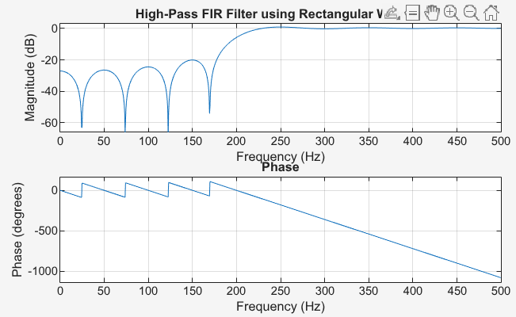
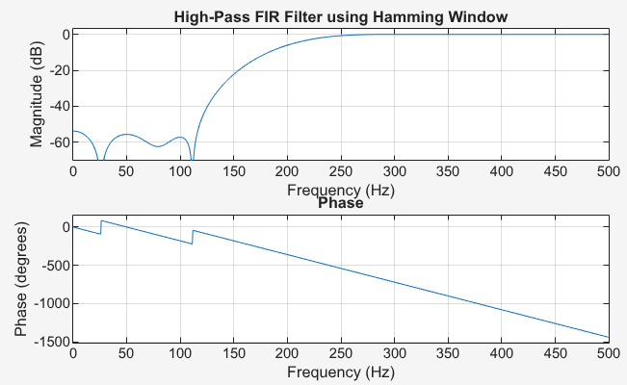
title('High-Pass FIR Filter using Rectangular Window');

Hamming window provides a good compromise between transition width and stopband attenuation. Compared to the Rectangular window, the Hamming window reduces ripples in the stopband while still maintaining a reasonably sharp cutoff for the high-pass filter.

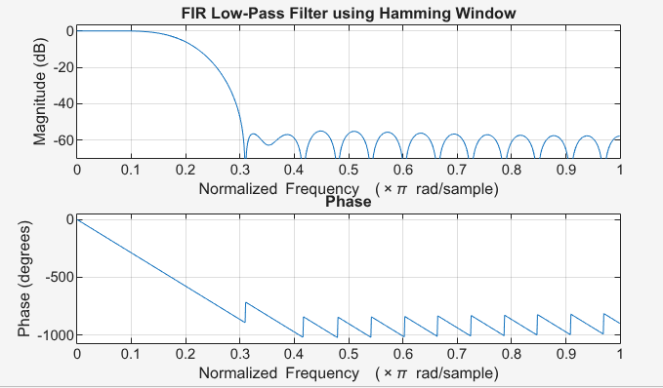
LAB1
clc; clear; close all;
% Specifications
wc = 0.2*pi;
A_s = 50; % hamming filter
N = 33;
% Normalized wc (0 to 1, Nyquist = 1)
Wn = wc/pi;
% Design FIR LPF using Hamming Window
h_hamming = fir1(N-1,Wn,'low', hamming(N));
% Plot Frequency Response
freqz(h_hamming, 1, 1024);
title('FIR Low-Pass Filter using Hamming Window');

LAB2
clc;
clear;
close all;
% Given Parameters
R = 113;
N = R;
Fs = 4*N;
A = 21;
% Frequency specifications (MHz)
fp1 = N - 5;
fp2 = N + 5;
% Stopband edges (1 MHz transition)
fs1 = fp1 - 1;
fs2 = fp2 + 1;
% Normalized frequencies (0 to 1)
fn = Fs/2;
Wn = [fp1 fp2] / fn;
% FIR Filter Design using Hamming Window
filter_order = 50;
h_hamming = fir1(filter_order, Wn, 'bandpass', hamming(filter_order+1));
% Frequency Response
freqz(h_hamming, 1, 1024, Fs)

i) Explain with reason which filter type you would prefer based on the specifications

A linear-phase FIR band-pass filter is preferred for the radar receiver. The radar echo’s waveform must not be distorted, so linear phase is required. Linear phase means all frequencies are delayed equally, preserving the signal shape. IIR filters are not suitable because they have non-linear phase distortion. Therefore, a linear-phase FIR filter best meets the given specifications.

We use Hamming window in FIR because it guarantees linear phase while controlling unwanted frequencies. The Hamming window shapes the FIR coefficients so that side-lobes are reduced, giving better stopband attenuation.

ii) Compute the normalized values of edge frequencies.

% Stopband edges (1 MHz transition)
fs1 = fp1 - 1;
fs2 = fp2 + 1;
% Normalized frequencies (0 to 1)
fn = Fs/2;
Wn = [fp1 fp2] / fn;

iii) Display the Magnitude response and Phase response of the designed filter.
